🡺MANDATORY HANDS ON

Exercise 1: Configuring a Basic Spring Application

Step 1: Set Up a Spring Maven Project

<project xmlns="http://maven.apache.org/POM/4.0.0"

xmlns:xsi="http://www.w3.org/2001/XMLSchema-instance"

xsi:schemaLocation="http://maven.apache.org/POM/4.0.0

http://maven.apache.org/xsd/maven-4.0.0.xsd">

<modelVersion>4.0.0</modelVersion>

<groupId>com.library</groupId>

<artifactId>LibraryManagement</artifactId>

<version>1.0-SNAPSHOT</version>

<dependencies>

<!-- Spring Core -->

<dependency>

<groupId>org.springframework</groupId>

<artifactId>spring-context</artifactId>

<version>5.3.34</version>

</dependency>

</dependencies>

</project>

Step 2: Configure applicationContext.xml

<?xml version="1.0" encoding="UTF-8"?>

<beans xmlns="http://www.springframework.org/schema/beans"

xmlns:xsi="http://www.w3.org/2001/XMLSchema-instance"

xsi:schemaLocation="

http://www.springframework.org/schema/beans

http://www.springframework.org/schema/beans/spring-beans.xsd">

<bean id="bookRepository" class="com.library.repository.BookRepository"/>

<bean id="bookService" class="com.library.service.BookService">

<property name="bookRepository" ref="bookRepository"/>

</bean>

</beans>

Step 3: Create Service and Repository Classes

package com.library.repository;

public class BookRepository {

public void getAllBooks() {

System.out.println("Fetching all books from the database...");

}

}

BookService Class

package com.library.service;

import com.library.repository.BookRepository;

public class BookService {

private BookRepository bookRepository;

// Setter for dependency injection

public void setBookRepository(BookRepository bookRepository) {

this.bookRepository = bookRepository; }

public void listBooks() {

System.out.println("BookService: Listing books...");

bookRepository.getAllBooks();

}

}

Step 4: Run the Application

package com.library;

import com.library.service.BookService;

import org.springframework.context.ApplicationContext;

import org.springframework.context.support.ClassPathXmlApplicationContext;

public class MainApp {

public static void main(String[] args) {

ApplicationContext context = new ClassPathXmlApplicationContext("applicationContext.xml");

BookService bookService = context.getBean("bookService", BookService.class);

bookService.listBooks();

}

}

Output

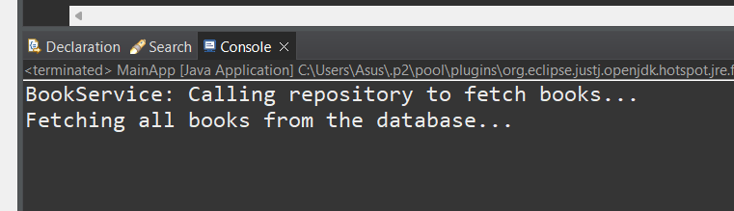

**Exercise 2: Implementing Dependency Injection**

**It is as same as** Exercise 1: Configuring a Basic Spring Application

OUTPUT

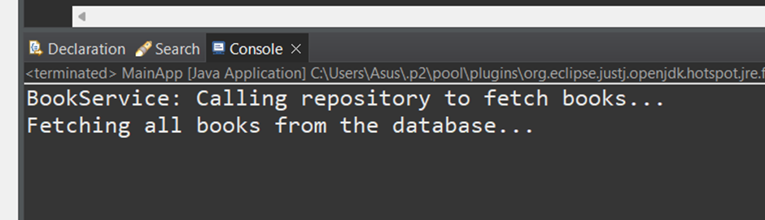

**Exercise 4: Creating and Configuring a Maven Project**

**Step1: Create a New Maven Project:**

package com.example.library;  
  
public class LibraryM {  
public static void main(String[] args) {  
System.out.println(" Maven Project is set up successfully with Spring dependencies!");  
}  
  
}

Step 2:Add Spring Dependencies in pom.xml:

<project xmlns="http://maven.apache.org/POM/4.0.0"

xmlns:xsi="http://www.w3.org/2001/XMLSchema-instance"

xsi:schemaLocation="http://maven.apache.org/POM/4.0.0

http://maven.apache.org/xsd/maven-4.0.0.xsd">

<modelVersion>4.0.0</modelVersion>

<groupId>com.library</groupId>

<artifactId>LibraryManagement</artifactId>

<version>0.0.1-SNAPSHOT</version>

<name>LibraryManagement</name>

<dependencies>

<!-- Spring Core Container -->

<dependency>

<groupId>org.springframework</groupId>

<artifactId>spring-context</artifactId>

<version>5.3.34</version>

</dependency>

<!-- Spring AOP -->

<dependency>

<groupId>org.springframework</groupId>

<artifactId>spring-aop</artifactId>

<version>5.3.34</version>

</dependency>

<!-- Spring Web MVC -->

<dependency>

<groupId>org.springframework</groupId>

<artifactId>spring-webmvc</artifactId>

<version>5.3.34</version>

</dependency>

</dependencies>

<!-- Compiler Plugin for Java 1.8 -->

<build>

<plugins>

<plugin>

<artifactId>maven-compiler-plugin</artifactId>

<version>3.10.1</version>

<configuration>

<source>1.8</source>

<target>1.8</target>

</configuration>

</plugin>

</plugins>

</build>

</project>

OUTPUT

